Table of Contents
PREAMBLE 1
QUESTION 1: TEAM! 1
QUESTION 2: COMMENTING 1
QUESTION 3: PLOTTING 4
3(a) PLOT RESULT 4
3(b) PLOT RESULT 4
3(c) PLOT RESULT 5
QUESTION 4: COMPLEX ROOTS 6
4(a) WRITE FUNCTION IN SEPARATE FILE (TEMPLATE PROVIDED) 6
4(b) ANSWER QUESTION 6
4(c) OUTPUT RESULTS 7

PREAMBLE
DO NOT REMOVE THE LINE BELOW clear;

QUESTION 1: TEAM!
======================= Thomas Hiendel

QUESTION 2: COMMENTING
=======================
% Copy and comment every line of the following MATLAB script. Say what
% each line is doing in your comment. Explain each MATLAB line by using
% no more than one comment line, as done in the first line below. Run and
% publish the script: a=zeros(1,5) % Generate and print a 1x5 row vector of zeros b=ones(3,2) % Generate a 3x2 grid of ones c=size(a); % Finds the size of a, which is 1 5 abs([-5.2 , 3]) % Finds absolute of -5.2, 3, which is 5.2000 3.0000 floor(3.6) % Rounds 3.6 down to 3 d=[1:-3.5:-9]; % Starts at 1 stepping in intervals of -3.5 to/before -9 f=d(2); g=sin(pi/2); % Sets f to -2.5, g to 1
K=[1.4, 2.3; 5.1, 7.8]; % Declares two row, two column 2D matrix m=K(1,2); % Sets m to the first row, second column (2.3) n=K(:,2); % Sets n to the second column, 2.3 and 7.8 comp = 3+4i; % Sets comp to the real and imaginary components real(comp) % Takes the real component of comp (3) imag(comp) % Takes the imaginary component of comp (4) abs(comp) % Takes the absolute value of the comp (5) angle(comp) % Finds the angle of comp (0.9273)
disp('haha, MATLAB is fun'); % Prints: haha, MATLAB is fun
3^2 % Squares 3 (9)
4==4 % Does a boolean check (True)
[2==8 3~=5] % Does two boolean checks in a matrix [False True] x=[1:2:8]; % Sets x to [1 3 5 7] y=[5 7 6 8]; % Sets y to [5 7 5 8]
q = zeros(10,1); % Sets q to 10 rows and one column of zeros for ii = 1:10 % Sets ii to 1, stepping up to 10 in intervals of 1 q(ii) = ii^2; % Sets row ii to ii^2 end figure(1021); % Creates empty figure meeting stem(x,y) % Makes a stem plot with our x and y values defined earlier hold on; % Prevents new plots from clearing out old plots plot(x,y, 'k', 'linewidth', 2) % Draws a solid black line plot(x,y,'+r', 'markersize', 20); % Draws red signs at the coordinate pairs hold off; % Disables hold above xlabel('Horizontal Axis') % Labels x axis as 'Horizontal Axis' ylabel('Vertical Axis') % Labels y axis as 'Vertical Axis'
- = 0 0 0 0 0
- =
1 1
1 1 1 1
ans = 5.2000 3.0000
ans = 3
ans = 3
ans = 4
ans = 5 ans = 0.9273 haha, MATLAB is fun ans = 9
ans = logical 1
ans = 1×2 logical array
0 1
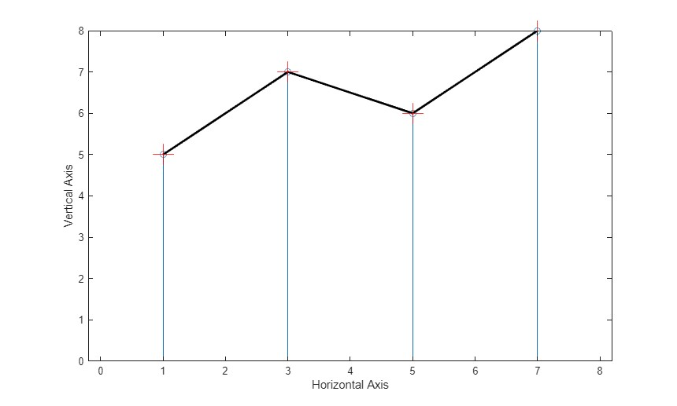

QUESTION 3: PLOTTING
=======================

3(a) PLOT RESULT
vect1 = [0 pi/4 2*pi/4 3*pi/4 4*pi/4 5*pi/4 6*pi/4 7*pi/4]; vect2 = cos(vect1); stem(vect1, vect2) xlabel('Angle (Radians)') ylabel('Amplitude')
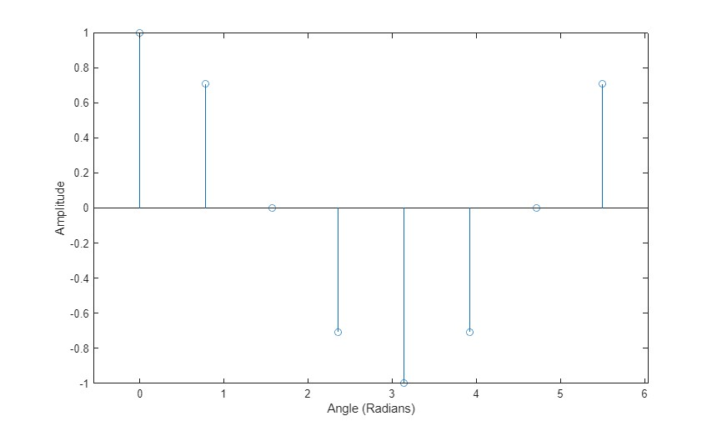

3(b) PLOT RESULT
theta = 0:pi/20:3*pi; y = cos(theta); plot(theta, y) xlabel('Angle (Radians)') ylabel('Amplitude')
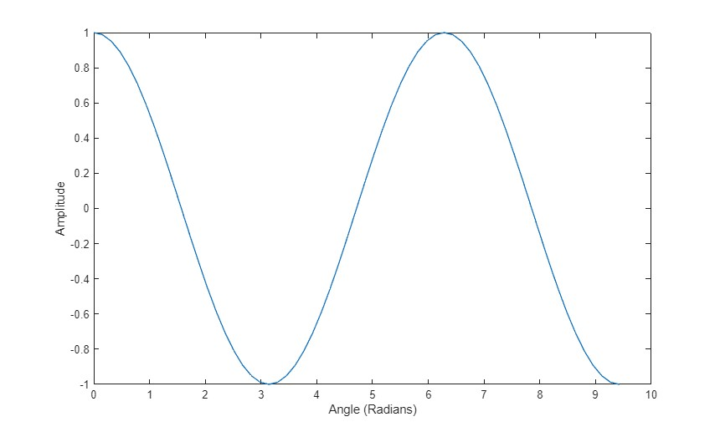

3(c) PLOT RESULT
time = -3:20*pi/1000:3; y = cos(time); plot(time, y) xlabel('Time (Seconds)') ylabel('Amplitude')
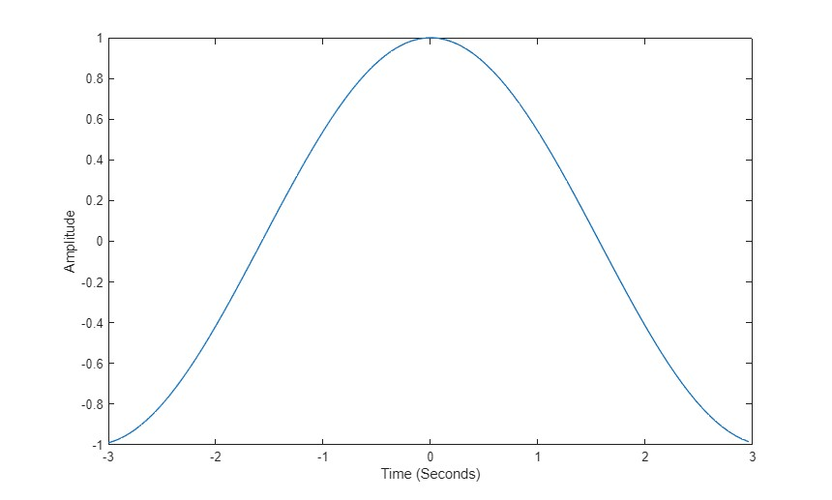

QUESTION 4: COMPLEX ROOTS
=======================

4(a) WRITE FUNCTION IN SEPARATE FILE (TEMPLATE PROVIDED)
type('myroots.m')
function r = myroots(n, a) myroots:
% Find all the nth roots of the complex number a
% Input Args: n: a positive integer specifying the nth roots a: a complex number whose nth roots are to be returned
% Output: r: 1xn vector containing all the nth roots of a
% A = abs(a); % Find the magnitude of the complex number
% phi = angle(a); % Find the phase (phi) of the complex number
% k = [0:1:n-1]; % Setting k to given value
% r = A^(1/n)*exp(j*(phi + 2*pi*k)/n) % Using root solve formula
% end

4(b) ANSWER QUESTION
help myroots % prints the documentation of the myroots function
myroots: Find all the nth roots of the complex number a Input Args:
n: a positive integer specifying the nth roots a: a complex number whose nth roots are to be returned
Output: r: 1xn vector containing all the nth roots of a

4(c) OUTPUT RESULTS
r = myroots(9,2) r = myroots(23,-j)
r = Columns 1 through 4 1.0801 + 0.0000i 0.8274 + 0.6942i 0.1876 + 1.0637i -0.5400 + 0.9354i
Columns 5 through 8 -1.0149 + 0.3694i -1.0149 - 0.3694i -0.5400 - 0.9354i 0.1876 - 1.0637i
Column 9 0.8274 - 0.6942i
r = Columns 1 through 4 1.0801 + 0.0000i 0.8274 + 0.6942i 0.1876 + 1.0637i -0.5400 + 0.9354i
Columns 5 through 8 -1.0149 + 0.3694i -1.0149 - 0.3694i -0.5400 - 0.9354i 0.1876 - 1.0637i
Column 9 0.8274 - 0.6942i
r = Columns 1 through 4 0.9977 - 0.0682i 0.9791 + 0.2035i 0.8879 + 0.4601i 0.7308 + 0.6826i
Columns 5 through 8
0.5196 + 0.8544i 0.2698 + 0.9629i 0.0000 + 1.0000i -0.2698 + 0.9629i Columns 9 through 12 -0.5196 + 0.8544i -0.7308 + 0.6826i -0.8879 + 0.4601i -0.9791 + 0.2035i
Columns 13 through 16 -0.9977 - 0.0682i -0.9423 - 0.3349i -0.8170 - 0.5767i -0.6311 - 0.7757i
Columns 17 through 20 -0.3984 - 0.9172i -0.1362 - 0.9907i 0.1362 - 0.9907i 0.3984 - 0.9172i
Columns 21 through 23 0.6311 - 0.7757i 0.8170 - 0.5767i 0.9423 - 0.3349i
r = Columns 1 through 4 0.9977 - 0.0682i 0.9791 + 0.2035i 0.8879 + 0.4601i 0.7308 + 0.6826i
Columns 5 through 8 0.5196 + 0.8544i 0.2698 + 0.9629i 0.0000 + 1.0000i -0.2698 + 0.9629i
Columns 9 through 12 -0.5196 + 0.8544i -0.7308 + 0.6826i -0.8879 + 0.4601i -0.9791 + 0.2035i
Columns 13 through 16 -0.9977 - 0.0682i -0.9423 - 0.3349i -0.8170 - 0.5767i -0.6311 - 0.7757i
Columns 17 through 20 -0.3984 - 0.9172i -0.1362 - 0.9907i 0.1362 - 0.9907i 0.3984 - 0.9172i
Columns 21 through 23 0.6311 - 0.7757i 0.8170 - 0.5767i 0.9423 - 0.3349i
Published with MATLAB® R2025a

